gInstall Install Script Manual

**User Experience Flow**

1. User starts the policy from gInstall
2. If a startDialog was defined this will be displayed to the user and allow them to Cancel (Optional)
3. if a preInstall trigger was defined it will run (Optional)
4. if a download trigger was defined it will run with a progress bar shown to the user (Optional)
5. The cached dmg will be verified with a progress bar shown to the user
6. The contents of the dmg will be installed with a progress bar shown to the user
7. A Installation complete dialog will be shown to the user

Notes: Should any policy, download, verification or install fail the user will be prompted with an error message stating what error happened. They will be told to quit gInstall and verify they have a stable internet connection.

**Policy Setup**

1. Upload a dmg package that either contains pkgs or is a flat dmg to the JSS
2. Decide what deployment strategy this install should have
   1. Should the user have to confirm before install
   2. Should an additional policy triggers be used
3. Based on the deployment strategy either create a policy with 1_gInstall_Install.sh as a before or after script
4. Fill out the script variables based on the descriptions below

**Policy Set Variables**

**dmgName:** The filename of the dmg

example: ginstall.dmg

**installType:** Defines how the dmg will be installed

options

* DMG - Installs a flat DMG to the root of the system
* fut - Installs a flat DMG and installs the contents of the /Users to User Templates
* feu - Installs a flat DMG and installs the contents of the /Users to all existing users
* feu,fut - Installs a flat DMG and installs the contents of the /Users to all existing users and User Templates
* pkg - Mounts the DMG and installs all pkg and mpkg packages in the root of the dmg

**policyName:** The title for all dialog windows

example: Test gInstall Process

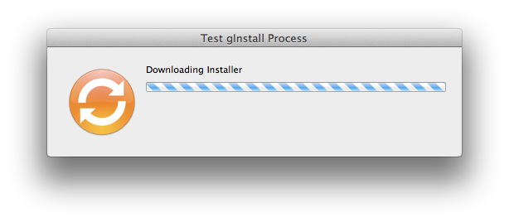

**startDialog:** If this is set an initial confirmation dialog with this text is displayed to the user. If this is blank no dialog will appear.

example: Things to say about stuff

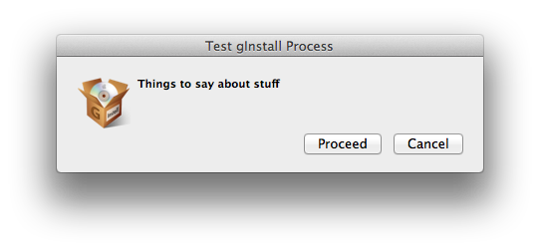

**preInstallTrigger:** If this is set prior to proceeding this policy trigger will run. There is no dialog to the user when this is being ran. This allows for the individual preInstall policies to have their own dialog defined if needed. If this is blank no preInstall trigger will be ran.

**downloadTrigger:** If this is set this policy trigger will be ran prior to any file verification. If this is blank no download trigger will be ran

**postTrigger:** If this is set this policy trigger will be ran after all installs have completed successfully. There is no dialog to the user when this is being ran. This allows for the individual postTrigger policies to have their own dialog defined if needed. If this is blank no post trigger will be ran.

**File Locations**

gInstall_install.log - /Library/Logs/gInstall/gInstall_install.log

gInstall Cache - /private/var/gne/gInstall/cache/

JAMF Cache - /Library/Application Support/JAMF/Waiting Room/